SRS Document

ONLINE BOOKMARKING APPLICATION

by-

Harjatin Singh:(12BCE0457)

Deepak : (12BCE0534)

To: Prof. Lydia Jane G.

**Problem Statement**

With an ever growing need for co creation and collaboration amongst technicians from various streams to create cross community projects, there also arises a need for a system that would enable innovators to easily find other people with the required skill set to help them take their idea forward. This is the most major problem that our system caters to.

**Background Information**

As we know that students, especially in the engineering community come up with ideas that have the capability make several day to day tasks easier. But it is often seen that these ideas are dashed to the ground due to lack of skill set possessed by one single person to bring this idea to reality.

It is in this scenario that an individual wishes for a system that would help him find people with the required skills to help him co create. The system should not only aid this process but also act as a medium to keep all the project members updated about the developments of the project using images, videos or comments. The system should also reflect the kind of work a person has done in terms of projects in the past. This would help other people pick their team members more wisely. The user would also want to have a profile displaying users’ skill set for other people to see.

**Stakeholders**

* Project Development and Design Team
* Users
* Mentors
* Other Project Management Tool Makers
* Recruiters

(Please refer Diagram for details)

**Requirements**

* **Functional Requirement**
  1. Log in
  2. Add New Project
  3. Send Project Join Request
  4. Accept Project Join Request
  5. Form a permanent team
  6. Create and Edit Profile
  7. Add notes and reminders
  8. Search Suitable Users

User Stories:

1. Register:   
   As a new user I would like to register on your web application. So that I can create new projects and find team members.
2. Login:   
   As an existing user, I would like to log in to my account to access my customised feed.
3. Add New Project:   
   As a current user of the application I would like to add a new project for which I will be the admin.
4. Send Join Project Request:   
   As a logged in user in your application I would like send a project join request to a suitable user for further development.
5. Accept Join Request:

As a user of the application I would like to accept requests from the project admin to join the project.

1. Create Team:

As a user of the application, I would want to create a team of members who usually work together so that I do not have to send requests every time I create a new project.

1. Add Notes:   
   As a user of the application I would like make notes and reminders regarding various projects and related deadlines.
2. Project Timeline:  
   As a user of the application I want to update project timeline so that I can keep rest of the members updated with what I have done.
3. Manage Profile:   
   As a registered user of the application I would like create and manage my profile so that people can know my skill set and approach me to work on related projects.

**Use Case Diagram:**

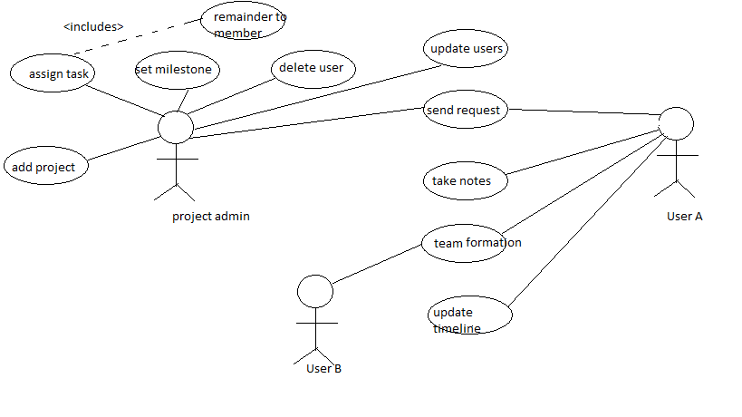

* **Non Functional Requirements**
* Privacy:  
  The users personnel details shall not be shared with any advertisement or funding agency without users’ consent.
* Security:   
  The application will be hosted on safe and secure cloud servers. All the registration information of the users will be safe and secure and will not be shared with any third party. All personnel information will be encrypted using state of the art techniques.
* Failure Management:  
  In case of any disaster or unexpected failure the user’s data will not be compromised because it will be stored on reliable servers. Periodic backup of user data will ensure ease of recovery.
* Price:   
  The application is free to use. No charges of any kind to use the application will be collected.
* Response time:   
  The response time of the application will depend on the bandwidth of the internet at which the user is accessing the application. However the minimum time to load the application from our server side will be not more than 1.5 sec.
* Usability:   
  It will be extremely easy to use the application. It would take about 3 minutes to get to know all the features of application and how to use it. The new user registration will take 30 seconds.
* Scalability:   
  The application will be designed keeping in mind the population using the internet and so there will be real time monitoring of number of users registering for it and the extra window will be implemented. Also since the application will be hosted on cloud based servers, they can be unscaled anytime according to requirement.